Enums

1. 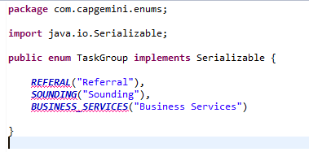

Reason for the exception 🡺 The constructor TaskGroup(String) undefined

So after adding constructor this vanishes

1. Now lets us consider an example of calling the above enum with the value that Is not present in it and see what is the exception we get

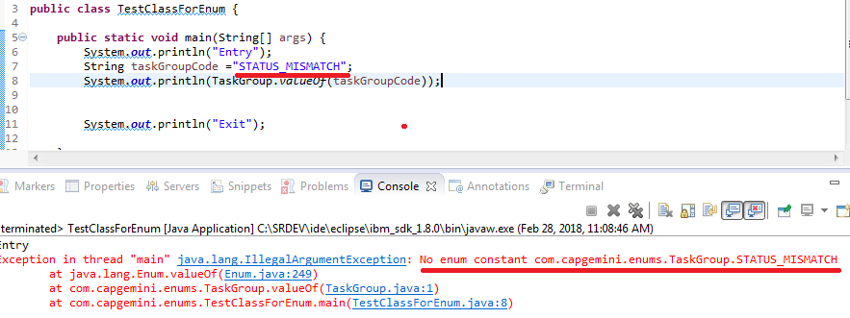

8/3/2018

1. [@ModelAttribute](http://static.springsource.org/spring/docs/3.1.x/javadoc-api/org/springframework/web/bind/annotation/ModelAttribute.html) refers to a property of the Model object (the M in MVC ;)
2. We can also use 🡺 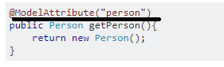
3. Static Pages in Spring MVC
4. <mvc:resources mapping="/resources/**" location="/, classpath:/WEB-INF/public-resources/" cache-period="10000" />
5. Here, the tag is being used to map static pages
6. <form:input> > tag is used to render an HTML text box.
7. 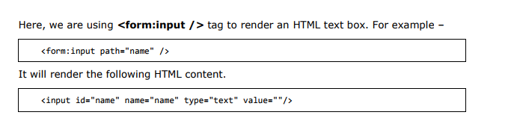
8. Input type Password in Spring 🡺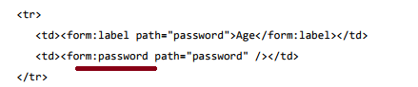

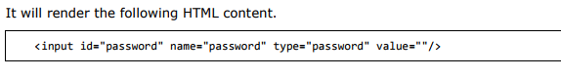

1. 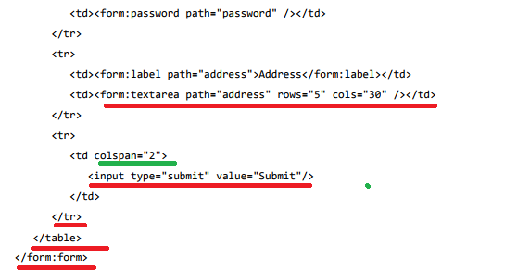
2. Now lets see for Checkbox in Spring 🡺 so till now we had seen name(text type), pwd(pwd type), address(text area) all this fields where of string type in Pojo but check box attribute is of type boolean

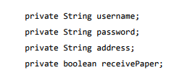

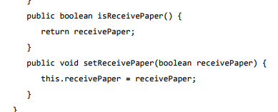

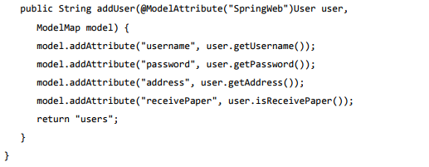

1. The following example explains how to use Multiple Checkboxes in forms using the Spring Web MVC framework.
2. 

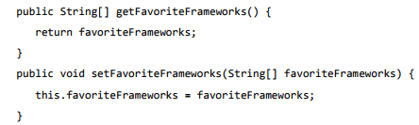

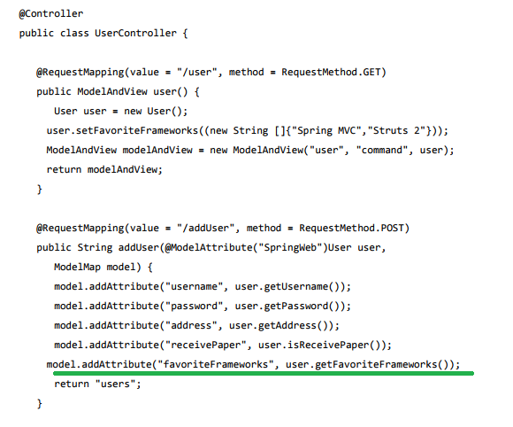

**************

Note 🡺 HERE WE HAVE TO SHOW LIST OF OPTIONS FOR MULTIPLE CHECKBOXES, FOR EXAMPLE 🡺

THUS WHERE DO WE SET THIS ? IS IT IN THE FORM? 🡺

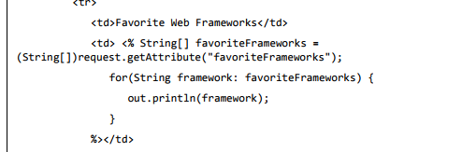

NOW IN THE FORM FROM WHERE DO WE GET THIS VALUE?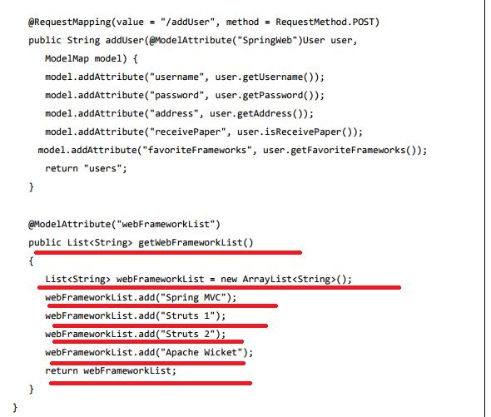

NOTE HERE I WANT MORE UNDERSTANDING

****************************

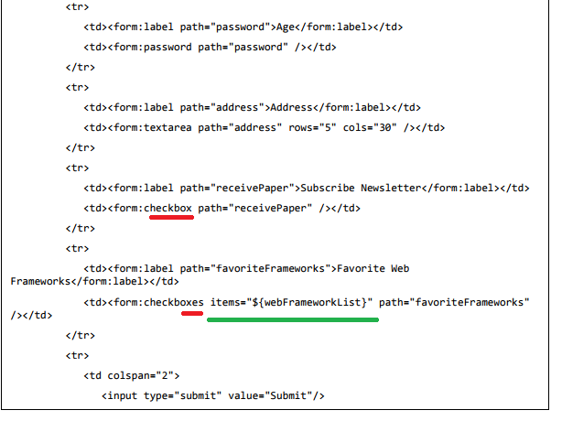

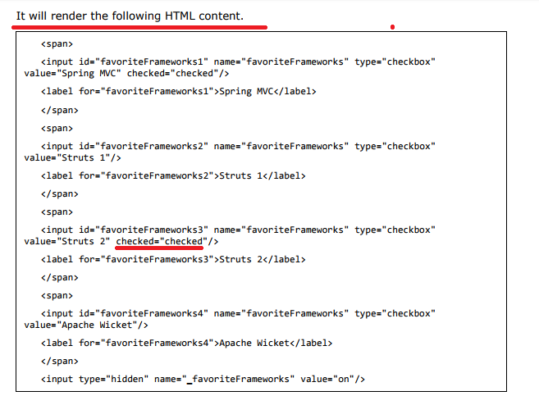

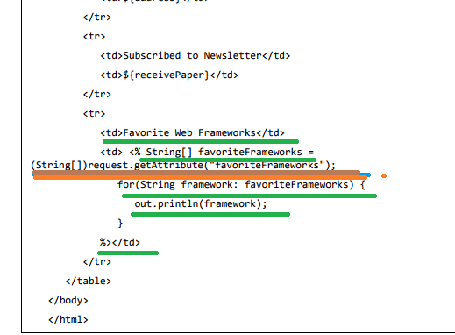

1. Radio Button 🡺
2. type in java is String



1. 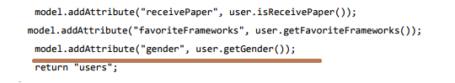
2. 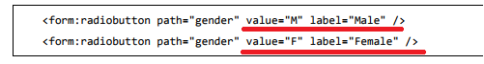

NOTE SEE IN THE ABOVE FIGURE “value="M" label="Male" “ is extra

1. 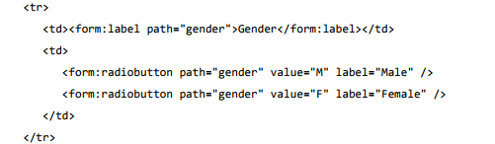

Spring MVC – RadioButtons

1. UI🡺 
2. 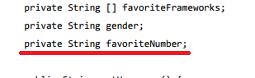
3. 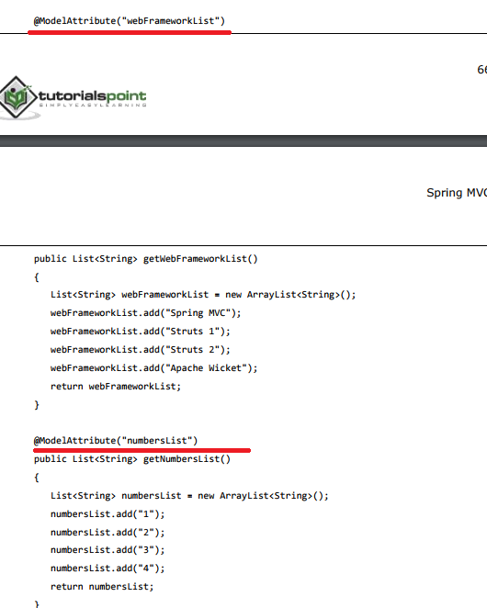
4. 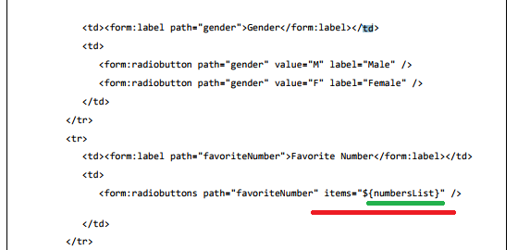

NOTE 🡺 GREEN COLOUR IS USED IN @ModelAttribute(“numbersList”)

Hidden Field 🡺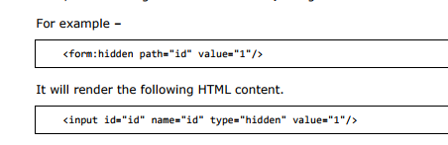

Spring MVC – Error Handling

1. Later

Spring MVC – BeanName URL Handler Mapping

1. The BeanNameUrlHandlerMapping class is the default handler mapping class, which maps the URL request(s) to the name of the beans mentioned in the configuration.
2. 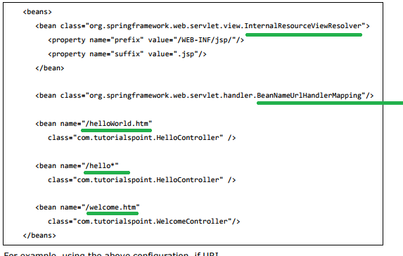

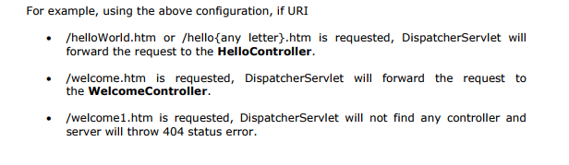

Difference between System.gc() and Object.finalize()

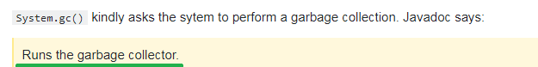

And

Object.finalize() can be overriden to specify what to do when a given object is garbage collected (actually what to do just before it is garbage collected).

**How to execute a stored procedure?**

**Purpose of ng serve and ng build**

**Flow of Scheduler to Rest service**

1. 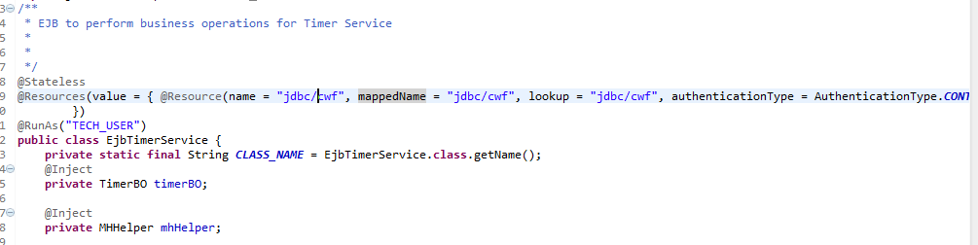
2. 